6.12: (a) Estimate: 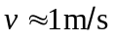 (walking)
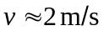 (running)
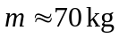
Walking: 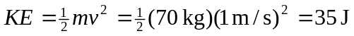
Running: 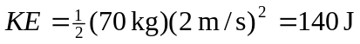
(b) Estimate: 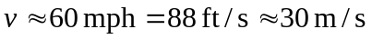
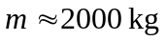
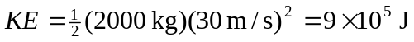
(c) 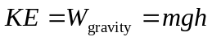 Estimate 